Trade of Metal Fabrication
Module 6: | Fabrication Drawing
Unit 3: | Standard Conventions
 | Phase 2

Table of Contents
List of Figures 5
List of Tables 6
Document Release History 7
Module 6 – Fabrication Drawing 8
Unit 3 – Standard Conventions 8
Duration – 2 Hours 8
Learning Outcome: 8
Key Learning Points: 8
Training Resources: 8
Key Learning Points Code: 8
Types of Lettering 9
Lines 10
Height of Lettering 10
Application of Welding Symbols to Working Drawings 11
Standards and Conventions 12
Drawing Scales 13
Drawing Diagonal Scales 14
Use of Grid Technique 15
Drawing Layouts and Simplified Methods 18
Single-Part Drawing 18
Collective Single-Part Drawings 18
Assembly Drawings 21
Collective Assembly Drawing 22
Design Layout Drawings 22
Combined Details and Assembly Drawings 23
Exploded Assembly Drawings 23
Simplified Drawings 24
Machine Drawing 26
Abbreviations 30
Self Assessment 31
Answers to Questions 1-4. Module 6. Unit 3 34
Index 37

List of Figures
Figure 1 - Types of Lettering for Technical Drawings 8
Figure 2 - Types of Line for Technical Drawings 9
Figure 3 - Example of a Drawing Sheet Layout such as would be used in an Engineering Company 9
Figure 4 - Standards and Conventions 11
Figure 5 - Drawing Scales 12
Figure 6 - Drawing Diagonal Scales 13
Figure 7 - Freehand Drawing on an A3 Sheet of 10mm Square Grid Paper 14
Figure 8 - Example of a Freehand Drawing on 10mm Square Grid Paper 15
Figure 9 - Freehand Drawing of an Orthographic Projection on Plain Paper without Grid Lines 15
Figure 10 - Freehand Isometric Drawing on Isometric Grid Paper with Line Spacing at 10mm 16
Figure 11 - Freehand Drawing on Isometric Lines on Plain Paper without Grid Lines 16
Figure 12 - Bearing Insert 18
Figure 13 - Gear Hub 18
Figure 14 - Retaining Ring 19
Figure 15 - Collective Single-Part Drawing of a Rivet 19
Figure 16 - Assembly Drawing of Gear and Bearing 20
Figure 17 - Typical Collective Assembly Drawing of a Nut with Bolts of Various Lengths 21
Figure 18 - Combined Detail and Assembly Drawing of Hub-Puller 22
Figure 19 - Symmetrical Gasket and Half Gasket 23
Figure 20 - When Dimensioning Add Drawing Note 'Slot on one Side only' 23
Figure 21 - Symmetrical Joint Ring 23
Figure 22 - Part of a Lever Detail Drawing Symmetrical about the Horizontal Axis 24
Figure 23 - Peg-Board 24
Figure 24 - Gauze Filter 24
Figure 25 - Knurled Screws 24
Figure 26 - Features Found on Machine Drawings 25
Figure 27 - Abbreviations 29

List of Tables
Table 1 - Elementary Weld Symbols 10

Document Release History
Date | Version | Comments
20/02/07 | First draft
12/12/13 | SOLAS

Module 6 – Fabrication Drawing

Unit 3 – Standard Conventions

Duration – 2 Hours

Learning Outcome:
By the end of this unit each apprentice will be able to:
- Select and use all the standard conventions connected with this programme

Key Learning Points:
Rk | Drawing sizes and scale.
Rk | Types of drawings in general arrangements / detailed.  (For more information see Module 6 Unit 1).
Rk | Reasons for using scales on drawings.
Rk | Types of title blocks.
Rk | Material lists.
Rk | Use of grid system.
Rk | Pencil types and application.  (For more information see Module 6 Unit 2).
Rk Sk | Types of lines – B.S. 308.
Rk | Sectional views – B.S. 308  (For more information see Module 5 Unit 4).
Rk Sk | Dimensioning technique – B.S. 308.
Rk Sk | Lettering – B.S. 308.
Rk Sk | Abbreviations and symbols.
Rk Sk | Weld symbols – B.S. 499.
P | Presentation of work, organisation.

Training Resources:
- Classroom plus full set of drawing equipment, instruments and paper

Key Learning Points Code:
M = Maths D= Drawing RK = Related Knowledge Sc = Science
P = Personal Skills Sk = Skill H = Hazards

Types of Lettering
Figure 1 shows the type of lettering which should be used in technical drawings. Lettering should be simple, so that it can be easily read. As mentioned above, the height of letters should vary according to the size of drawing sheet in use. Notes and dimension lettering and figures should be drawn at a lower height than title block lettering. For example, on A4 sheets 3 mm high notes and dimension figures would be suitable, on an A2 sheet a height of 5 or 6 mm would be better.

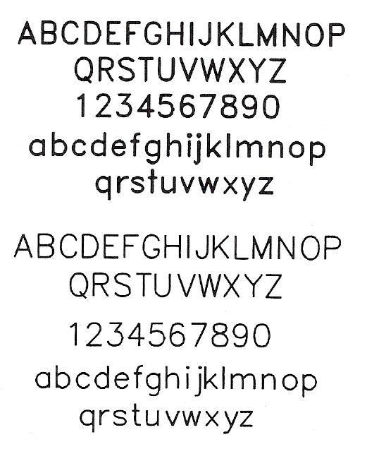
Figure 1 - Types of Lettering for Technical Drawings

Lines
Figure 2 shows some of the types of lines. Note that the lines of the outline of drawings should be thicker than other lines. This makes the outline stand out clearly against the other details in your drawings.
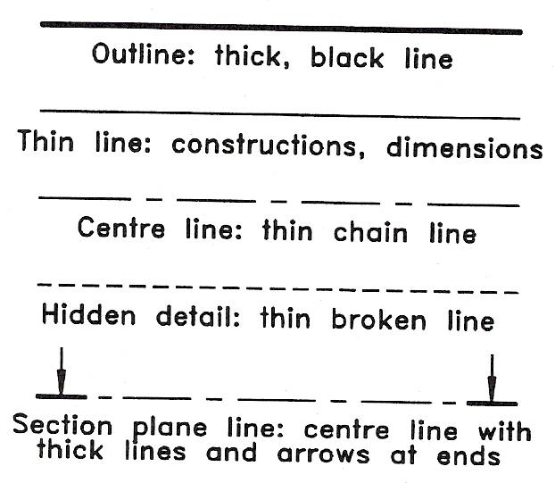
Figure 2 - Types of Line for Technical Drawings

Height of Lettering
In title blocks, features such as names, article titles, etc. are usually printed in capital letters. Their height will vary according to the size of the drawing sheet in use. Suggested heights are 6 mm for A4 sheets, 8 mm for A3 sheets and 10 mm for A2 sheets.
Figure 3 shows a type of sheet layout, which may be found in use by engineering companies. The sheets will be pre-printed so that draughtsmen can start working on the sheet without having to add details such as those shown in the title block. Note also the set of reference numbers around the margins of this sheet - anyone using the drawing can indicate any part by reference to the marginal letters and figures.
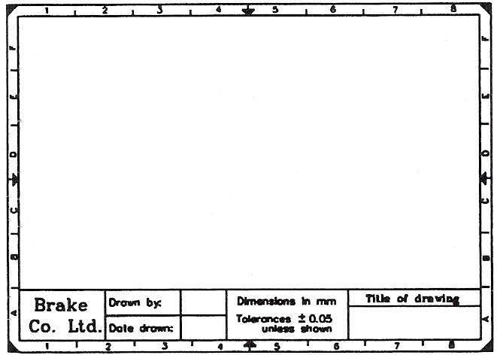
Figure 3 - Example of a Drawing Sheet Layout such as would be used in an Engineering Company

Application of Welding Symbols to Working Drawings

The following notes are meant as a guide to the method of applying the more commonly used welding symbols relating to the simpler types of welded joints on engineering drawings. Where complex joints involve multiple welds it is often easier to detail such constructions on separate drawing sheets.

Each type of weld is characterised by a symbol given in Table 1. Note that the symbol is representative of the shape of the weld, or the edge preparation, but does not indicate any particular welding process and does not specify either the number of runs to be deposited or whether or not a root gap or backing material is to be used. These details would be provided on a welding procedure schedule for the particular job.

It may be necessary to specify the shape of the weld surface on the drawing as flat, convex or concave and a supplementary symbol is then added to the elementary symbol.

A joint may also be made with one type of weld on a particular surface and another type of weld on the back and in this case elementary symbols representing each type of weld used are added together.

A welding symbol is applied to a drawing by using a reference line and an arrow line. The reference line should be drawn parallel to the bottom edge of the drawing sheet and the arrow line forms an angle with the reference line. The side of the joint nearer the arrowhead is known as the 'arrow side' and the remote side as the 'other side'.
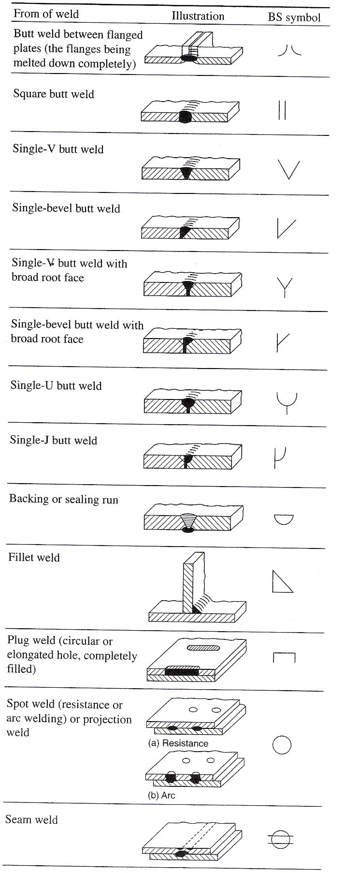
Table 1 - Elementary Weld Symbols

Standards and Conventions

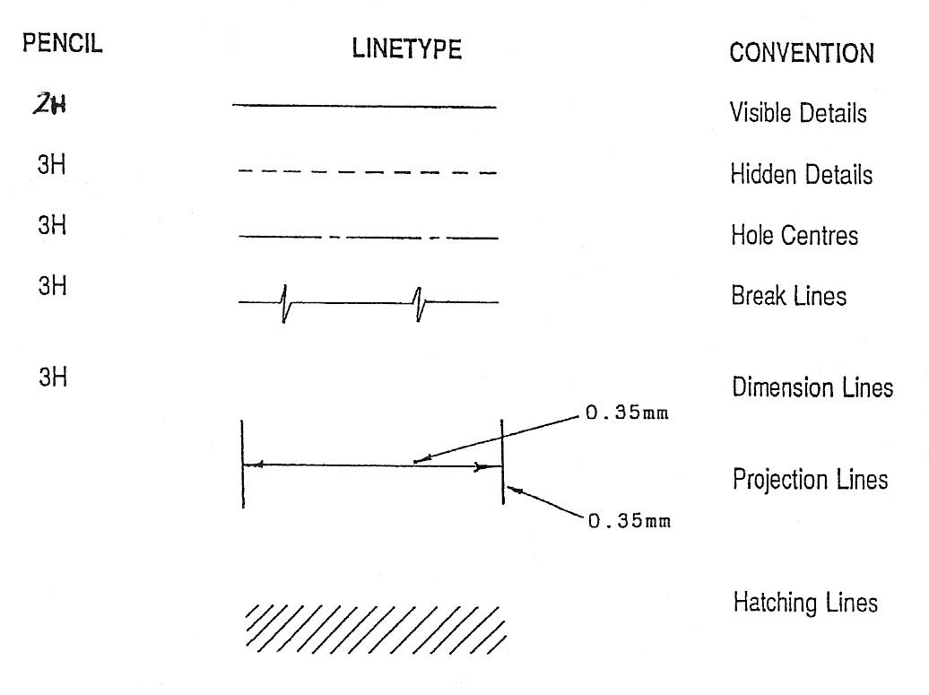
Figure 4 - Standards and Conventions

Drawing Scales
Many technical drawings will be drawn to scales in which the drawing is either smaller or larger than it’s correct full-size. When drawing to a scale all parts of the drawing are reduced or enlarged by the scale factor. Common scales in use with the metric system of measurement are:
- In engineering drawings - 1:2; 1:5; 1:10; 2:1; 5:1.
- In building drawings - 1:20; 1:50; 1:100; 1:200.

Drawing 1 (Figure 5) - Constructing a scale of 1:5. Each 1 mm on the drawing represents 5 mm on the item being drawn.
- Draw line AB 150 mm long. Draw CD at 5 mm parallel to AB.
- Divide AB into 3 equal parts - measuring with a ruler. Draw verticals 10 mm high at the division points.
- Divide the first 50 mm AE of AB into 10 equal parts.
- Complete the scale as shown in Figure 5.
Note: two examples of taking scaled measurements from the scale are shown in Figure 5. Examine the scale and you will understand why the scale is numbered with 0 being at the first division point along AB.

Drawing 2 (Figure 5) - Constructing a scale of 60 mm represents 1 metre.
- Draw FG 240 mm long. Then draw HJ at 5 mm parallel to EF.
- Divide FG into 4 equal parts and draw verticals at the divisions 10 mm high.
- Divide the first 60 mm of FG into 10 equal parts.
- Complete the scale as shown in Figure 5.
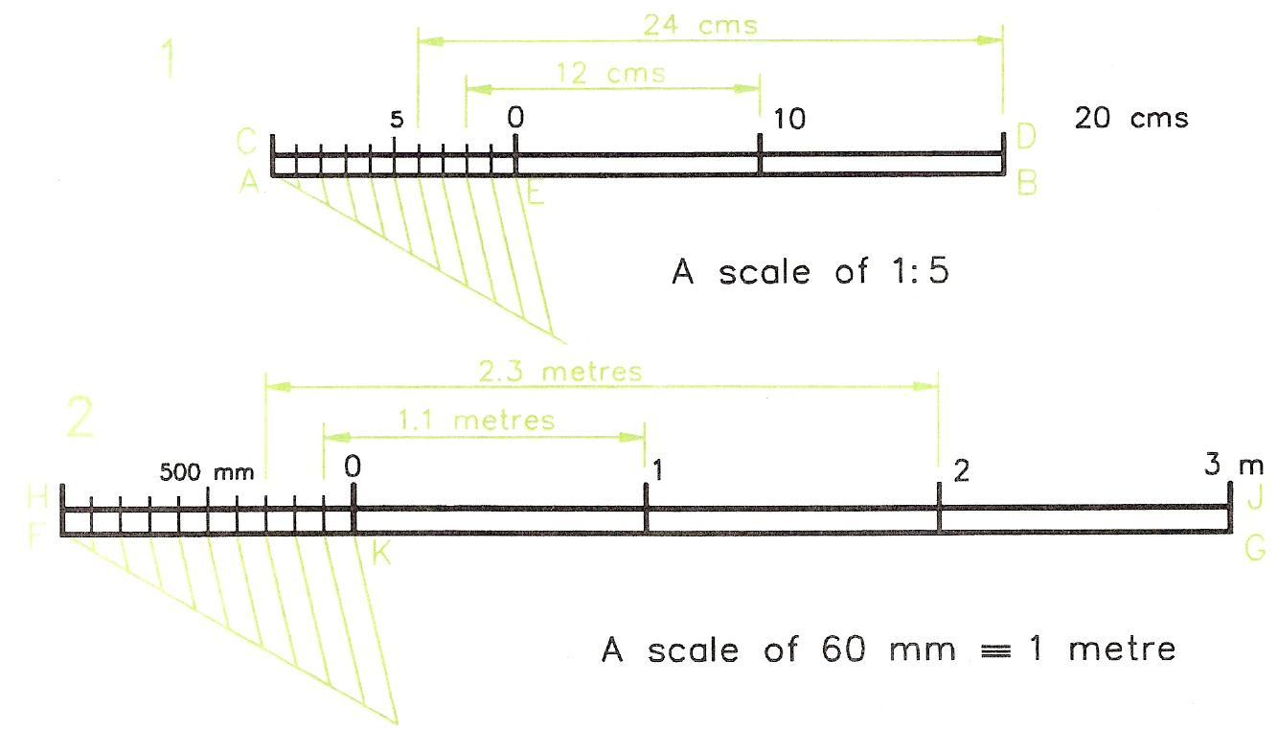
Figure 5 - Drawing Scales

Drawing Diagonal Scales
Diagonal scales are used where great accuracy is required. If accurately drawn, measurement down to millimetres in scales, such as 1:2 or 1:5, can be made with the aid of these scales. The scale to be constructed in this example is one of 1:2.5 to read in millimetres up to 300 mm.
Stage 1- To a scale of 1:2.5, 100 mm is represented by 40 mm.
- Draw AB 120 mm long.
- Step off three 40 mm divisions along AB.
- Draw verticals at the division points.
- Draw 10 lines above and parallel to AB at distances of 3 mm apart.
Stage 2
- Divide the first 40 mm division DE into 10 equal parts.
Stage 3
- Draw a line from the first 1/10 division from E to the first division point F on AB.
- Draw parallels to the line just drawn as shown in Figure 6.
- Number the scale as shown in Figure 6.
Note: the bottom drawing of Figure 6 shows how measurements greater than 100 mm are taken from a diagonal scale. The sequence is:
- Centre a compass or a pair of dividers on the vertical line for the hundreds part of the measurement, where the horizontal line for the last figure of the measurement meets the vertical 100s line.
- Read off the 10s figure of the measurement figure from the 10s figures along the bottom of the first 40 mm division of the scale.
- Set the compass or dividers to the resulting position on the scale.
- Mark off the length with the compass or the dividers on to the scaled drawing.
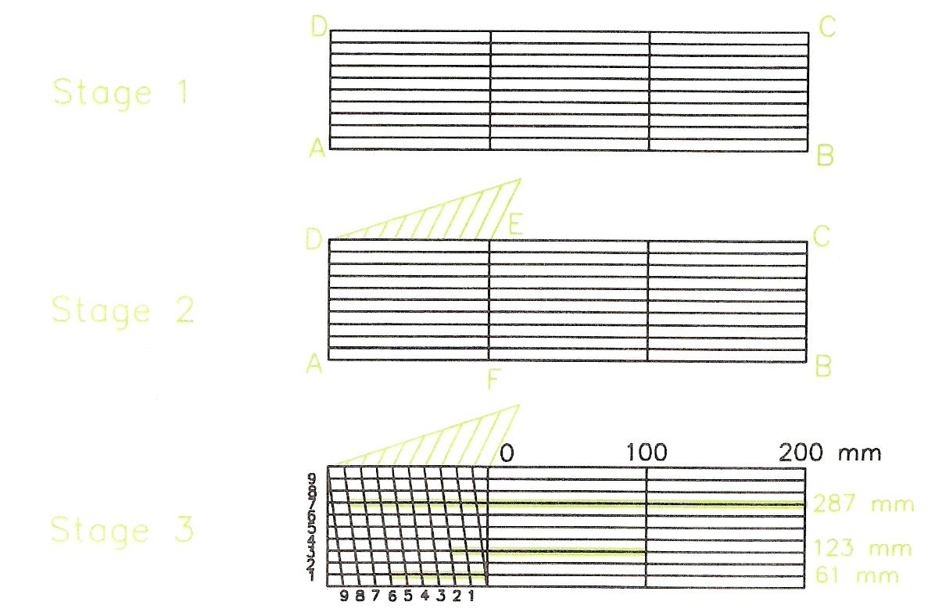
Figure 6 - Drawing Diagonal Scales

Use of Grid Technique
For preparing the layouts for orthographic drawings and for the necessary preparation work when square grid papers are available, a good tip is to start learning how to draw freehand sketches on grid papers. Such grid papers can be purchased in A4 or A3 sheets with the grid lines printed in green or blue - either square grids or isometric grids are available. The spacing of the grid lines is either at 10 mm intervals or at 5 mm intervals. However, when you have gained sufficient skill in freehand drawing with the aid of grid papers, it is best to then sketch on plain paper without the grid lines. The examples given in this book are for freehand sketching on either the lines of orthographic projection or isometric drawing.

An example of a freehand drawing of a pedestal mounting as preparation for the layout of the drawing before constructing the views of an orthographic projection are shown in three examples - Figure 7 on an A3 sheet of 10 mm square grid paper, Figure 8 on a smaller sheet of grid paper and Figure 9 on plain paper without a grid. Figure 10 shows a freehand isometric drawing on isometric grid paper with the grid at 10 mm spacing. Figure 11 is a similar freehand drawing on isometric lines on plain paper without grid lines.

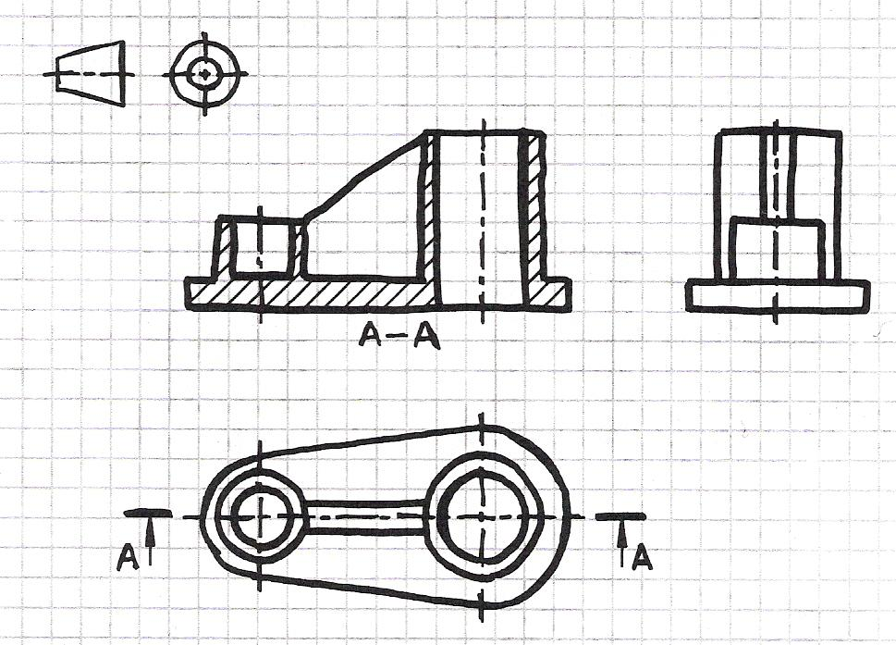
Figure 7 - Freehand Drawing on an A3 Sheet of 10mm Square Grid Paper

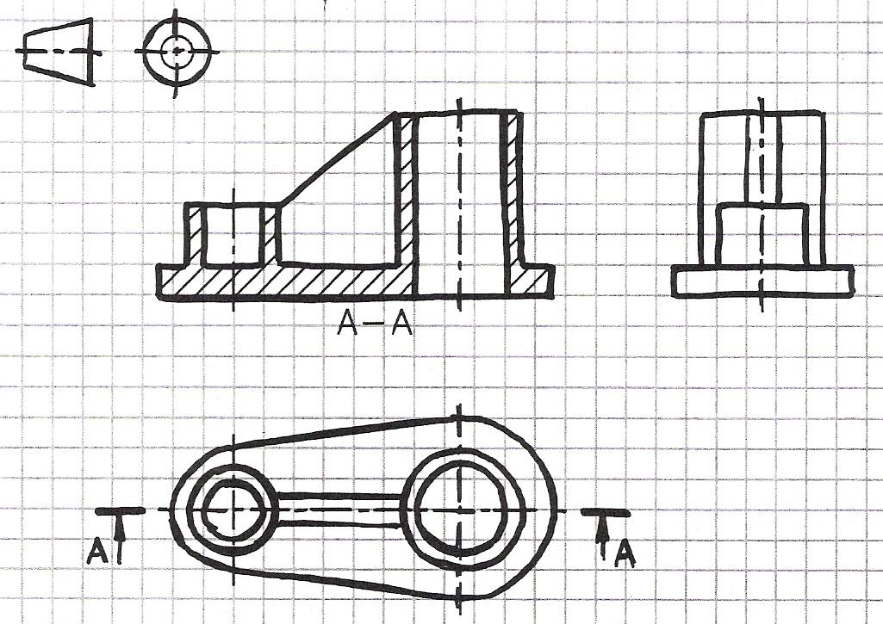
Figure 8 - Example of a Freehand Drawing on 10mm Square Grid Paper

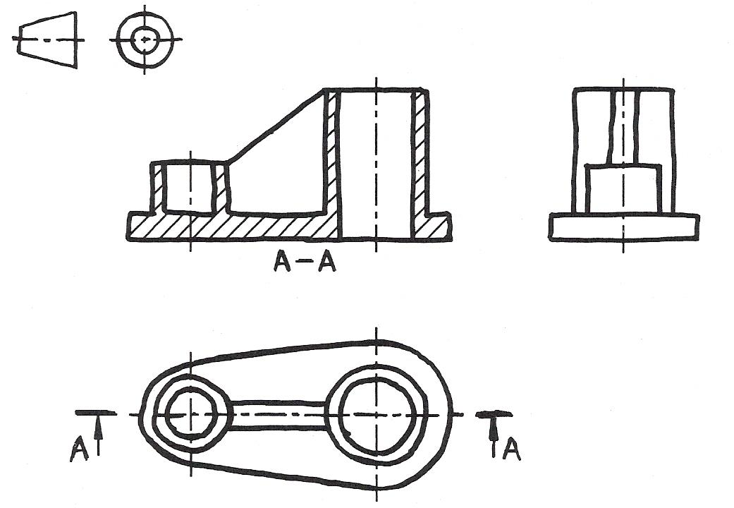
Figure 9 - Freehand Drawing of an Orthographic Projection on Plain Paper without Grid Lines
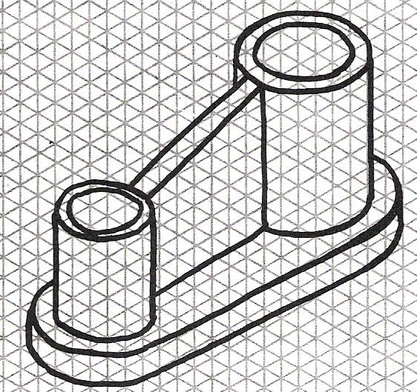
Figure 10 - Freehand Isometric Drawing on Isometric Grid Paper with Line Spacing at 10mm

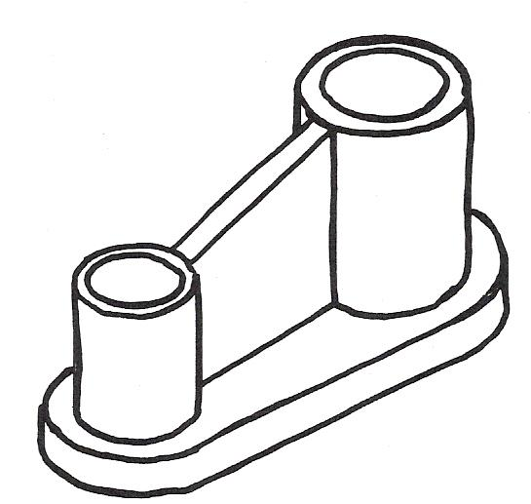
Figure 11 - Freehand Drawing on Isometric Lines on Plain Paper without Grid Lines

Drawing Layouts and Simplified Methods

Single-Part Drawing
A single-part drawing should supply the complete detailed information to enable a component to be manufactured without reference to other sources. It should completely define shape or form and size, and should contain a specification. The number of views required depends on the degree of complexity of the component. The drawing must be fully dimensioned, including tolerances where necessary, to show all sizes and locations of the various features. The specification for the part includes information relating to the material used and possible heat-treatment required, and notes regarding finish. The finish may apply to particular surfaces only, and may be obtained by using special machining operations or, for example, by plating, painting, or enamelling. Figure 12, Figure 13 and Figure 14 show typical single-part drawings.

An alternative to a single-part drawing is to collect several small details relating to the same assembly and group them together on the same drawing sheet. In practice, grouping in this manner may be satisfactory provided all the parts are made in the same department, but it can be inconvenient where, for example, pressed parts are drawn with turned components or sheet-metal fabrications.

More than one drawing may also be made for the same component. Consider a sand-cast bracket. Before the bracket is machined, it needs to be cast; and before casting, a pattern needs to be produced by a pattern maker. It may therefore be desirable to produce a drawing for the pattern maker, which includes the various machining allowances, and then produce a separate drawing for the benefit of the machinist, which shows only dimensions relating to the surfaces to be machined and the size of the finished part. The two drawings would each have only parts of the specification, which suited one particular manufacturing process.

Collective Single-Part Drawings
Figure 15 shows a typical collective single-part drawing for a. rivet. The drawing covers 20 rivets similar in every respect except length; in the example given, the part number for a 30 mm rivet is 5123/13. This type of drawing can also be used where, for example, one or two dimensions on a component (which are referred to on the drawing as A and B) are variable, all others being standard. For a particular application, the draughtsman would insert the appropriate value of dimensions A and B in a table, then add a new suffix to the part number. This type of drawing can generally be used for basically similar parts.
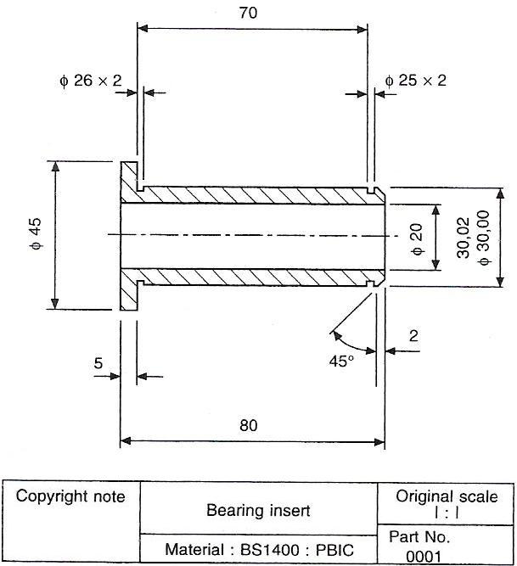
Figure 12 - Bearing Insert

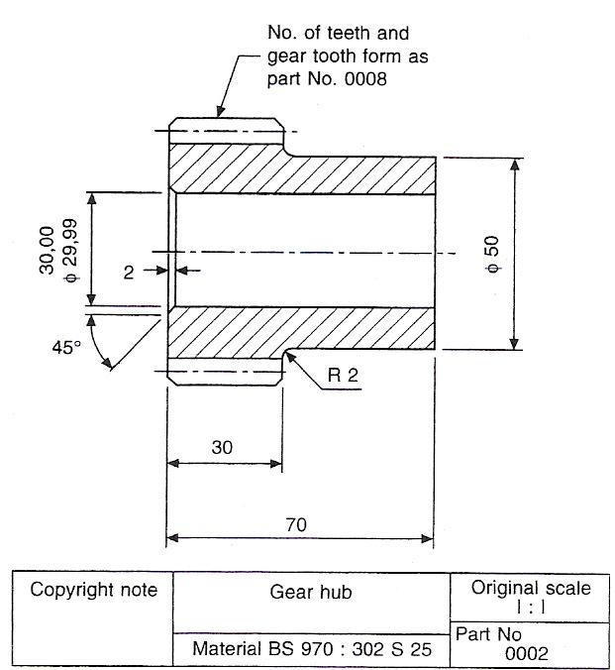
Figure 13 - Gear Hub
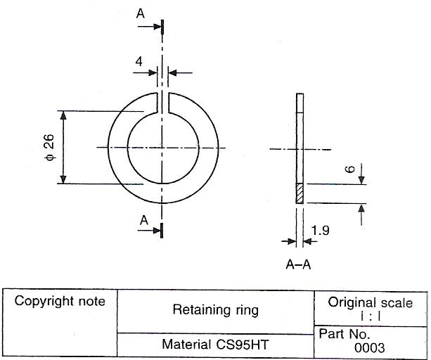
Figure 14 - Retaining Ring

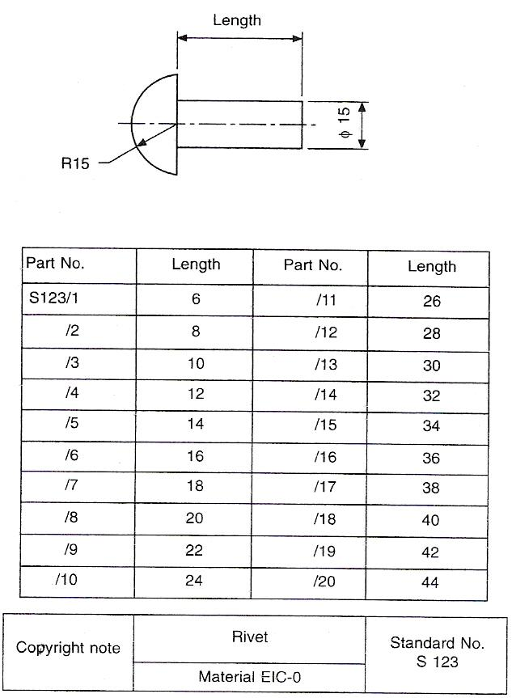
Figure 15 - Collective Single-Part Drawing of a Rivet

Assembly Drawings
Machines and mechanisms consist of numerous parts, and a drawing, which shows the complete product with all its components in their correct physical relationship, is known as an assembly drawing. A drawing that gives a small part of the whole assembly is known as a sub-assembly drawing. A sub-assembly may in fact be a complete unit in itself; for example, a drawing of a clutch could be considered as a sub-assembly of a drawing showing a complete automobile engine. The amount of information given on an assembly drawing will vary considerably with the product and its size and complexity.
If the assembly is relatively small, information that might be given includes a parts list. The parts list, as the name suggests, lists the components, which are numbered. Numbers in 'balloons' with leader lines indicate the position of the component on the drawing (see Figure 16). The parts list will also contain information regarding the quantity required of each component for the assembly, its individual single-part drawing number, and possibly its material. Parts lists are not standard items, and their contents vary from one drawing office to another.
The assembly drawing may also give other information, including overall dimensions of size, details of bolt sizes and centres where fixings are necessary, weights required for shipping purposes, operating details and instructions, and also, perhaps, some data regarding the design characteristics.
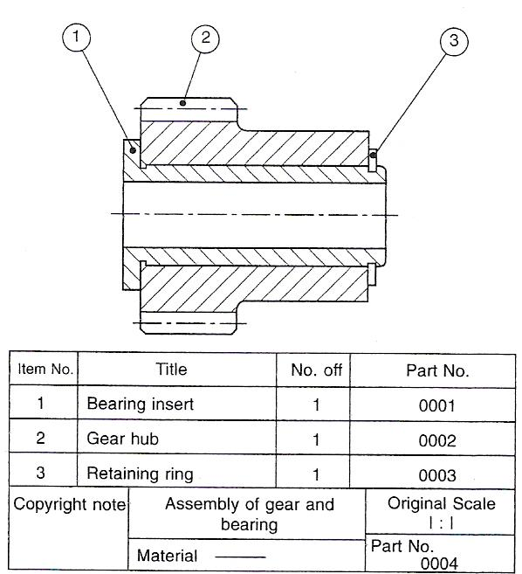
Figure 16 - Assembly Drawing of Gear and Bearing

Collective Assembly Drawing
This type of drawing is used where a range of products, which are similar in appearance but differing in size is manufactured and assembled. Figure 17 shows a nut-and-bolt fastening used to secure plates of different combined thickness; the nut is standard, but the bolts are of different lengths. The accompanying table is used to relate the various assemblies with different part numbers.
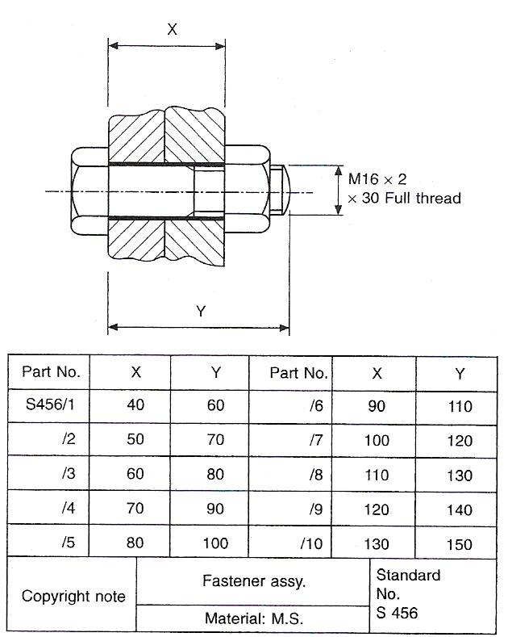
Figure 17 - Typical Collective Assembly Drawing of a Nut with Bolts of Various Lengths

Design Layout Drawings
Most original designs are planned in the drawing office where existing or known information is collected and used to prepare a provisional layout drawing before further detailed design work can proceed. This type of drawing is of a preliminary nature and subject to much modification so that the designer can collect his thoughts together. The drawing can be true to scale or possibly enlargements or reductions in scale depending on the size of the finished product or scheme, and is essentially a planning exercise. They are useful in order to discuss proposals with prospective customers or design teams at a time when the final product is by no means certain, and should be regarded as part of the design process.
Provisional layout drawings may also be prepared for use with tenders for proposed work where the detailed design will be performed at a later date when a contract has been negotiated, the company being confident that it can ultimately design and manufacture the end product. This confidence will be due to experience gained in similar schemes undertaken previously.

Combined Details and Assembly Drawings
It is sometimes convenient to illustrate details with their assembly drawing on the same sheet. This practice is particularly suited to small 'one-off' or limited-production-run assemblies. It not only reduces the actual number of drawings, but also the drawing-office time spent in scheduling and printing. Figure 18 shows a simple application of an assembly on his type.
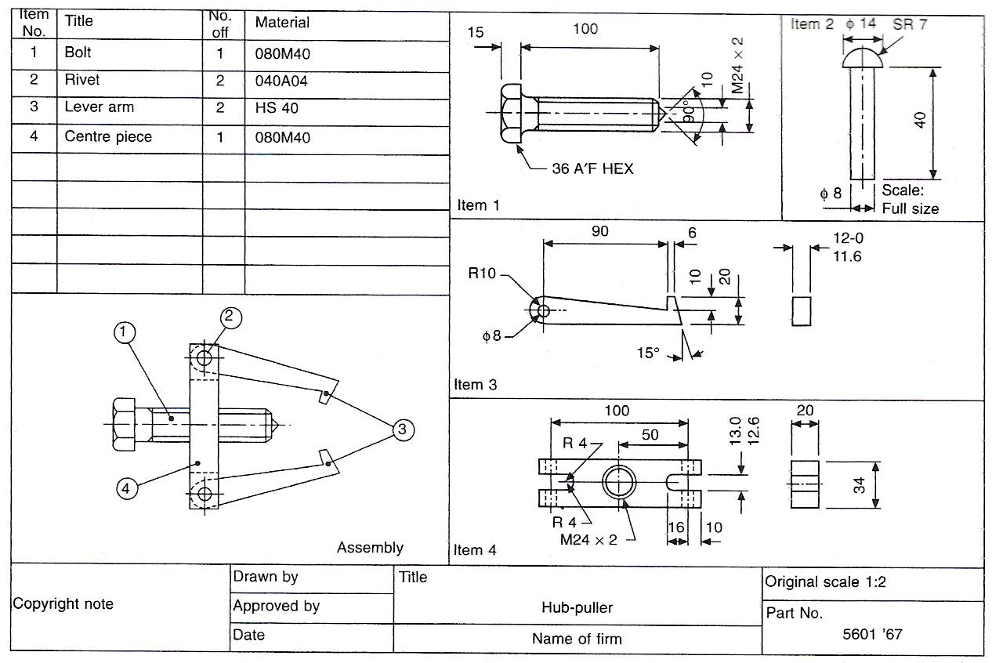
Figure 18 - Combined Detail and Assembly Drawing of Hub-Puller

Exploded Assembly Drawings
Generally a pictorial type of projection is used, so that each part will be shown in three dimensions. Exploded views are invaluable when undertaking servicing and maintenance work on all forms of plant and appliances. Car manuals and do-it-yourself assembly kits use such drawings, and these are easily understood. As well as an aid to construction, an exploded assembly drawing suitably numbered can also be of assistance in the ordering of spare parts; components are more easily recognisable in a pictorial projection, especially by people without training in the reading of technical drawings.

Simplified Drawings
Simplified draughting conventions have been devised to reduce the time spent drawing and detailing symmetrical components and repeated parts. Figure 19 shows a gasket, which is symmetrical about the horizontal centre line. A detail drawing indicating the line of symmetry and half of the gasket is shown in Figure 19, and this is sufficiently clear for the part to be manufactured.
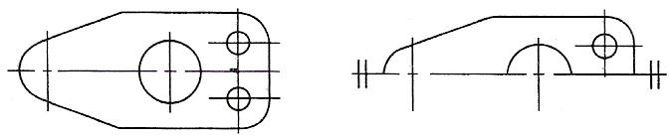
Figure 19 - Symmetrical Gasket and Half Gasket

If both halves are similar except for a small detail, then the half that contains the exception is shown with an explanatory note to that effect, and a typical example is illustrated in Figure 20.
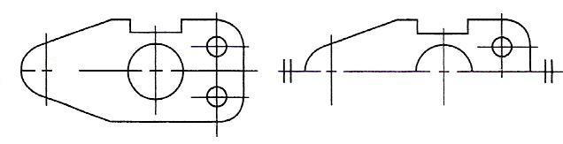
Figure 20 - When Dimensioning Add Drawing Note 'Slot on one Side only'

A joint-ring is shown in Fig. 7.10, which is symmetrical about two axes of symmetry. Both axes are shown in the detail, and a quarter view of the joint-ring is sufficient for the part to be made.
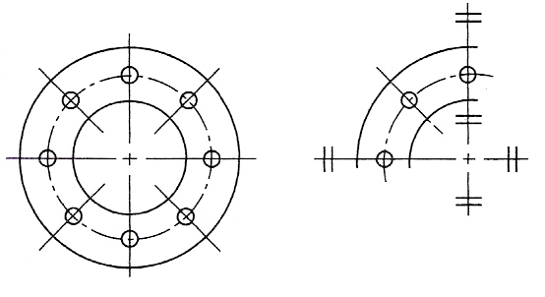
Figure 21 - Symmetrical Joint Ring
The practice referred to above is not restricted to flat thin components, and Figure 22 gives a typical detail of a straight lever with a central pivot in part section. Half the lever is shown, since the component is symmetrical, and a partial view is added and drawn to an enlarged scale to clarify the shape of the boss and leave adequate space for dimensioning.
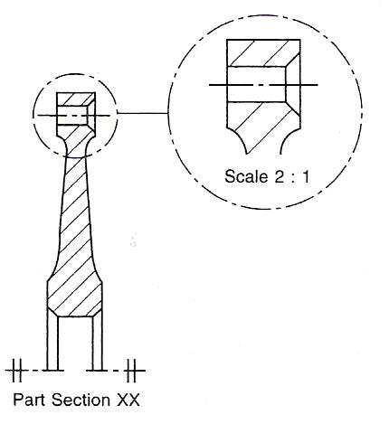
Figure 22 - Part of a Lever Detail Drawing Symmetrical about the Horizontal Axis

Repeated information also need not be drawn in full; for example, to detail the peg-board in Figure 23 all that is required is to draw one hole, quoting its size and fixing the centres of all the others.
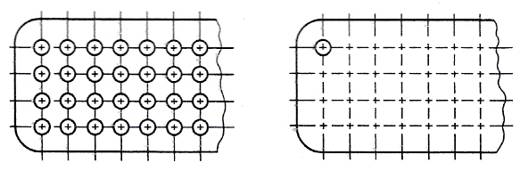
Figure 23 - Peg-Board

Similarly, Figure 24 shows a gauze filter. Rather than draw the gauze over the complete surface area, only a small portion is sufficient to indicate the type of pattern required.
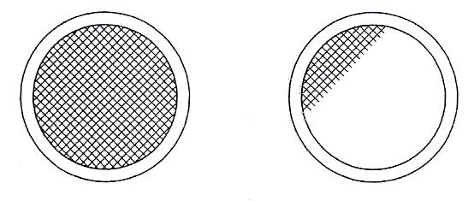
Figure 24 - Gauze Filter

Knurled screws are shown in Figure 25 to illustrate the accepted conventions for straight and diamond knurling.
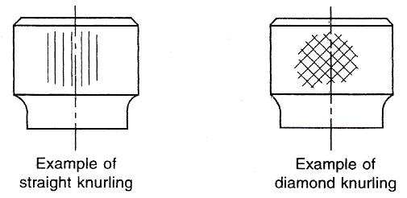
Figure 25 - Knurled Screws

Machine Drawing
The draughtsman must be able to appreciate the significance of every line on a machine drawing. He must also understand the basic terminology and vocabulary used in conjunction with machine drawings.
Machine drawings of components can involve any of the geometrical principles and constructions described in this book and in addition the accepted drawing standards covered by BS 8888.
Figure 26 illustrates many features found on machine drawings and the notes that follow give additional explanations and revision comments.

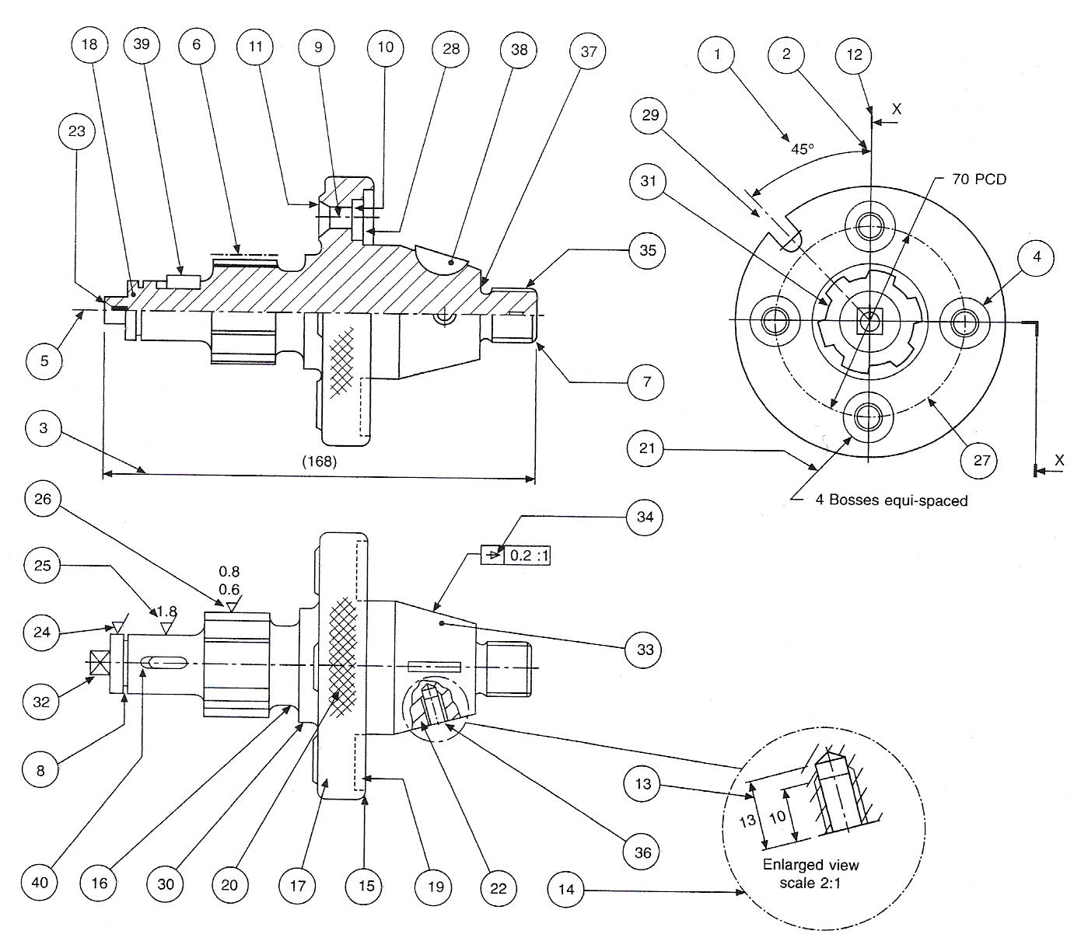
Figure 26 - Features Found on Machine Drawings

- Angular dimension - Note that the circular dimension line is taken from the intersection of the centre lines of the features.
- Arrowheads - The point of an arrowhead should touch the projection line or surface, it should be neat and easily readable and normally not less than 3 mm in length.
- Auxiliary dimension - A dimension given for information purposes but not used in the actual manufacturing process.
- Boss - A projection, which is usually circular in cross section, and often found on castings and forgings. A shaft boss can provide extra bearing support, for example, or a boss could be used on a thin cast surface to increase its thickness in order to accommodate a screw thread.
- Centre line - Long dashed dotted narrow line, which is used to indicate the axes of holes, components and circular parts.
- Long dashed dotted wide line - This is used to indicate surfaces which are required to meet special specifications and which differ from the remainder of the component.
- Chamfer - A chamfer is machined to remove a sharp edge. The angle is generally 45°. Often referred to as a bevelled edge.
- Circlip groove - A groove to accommodate a circlip. A circlip may be manufactured from spring steel wire, sheet or plate, which is hardened and tempered and when applied in an assembly provides an inward or outward force to locate a component within a bore or housing.
- Clearance hole - A term used in an assembly to describe a particular hole, which is just a little larger and will clear the bolt or stud which passes through.
- Counterbore - A counterbored hole may be used to house a nut or bolthead so that it does not project above a surface. It is machined so that the bottom surface of the larger hole is square to the hole axis.
- Countersink - A hole, which is recessed conically to accommodate the head of a rivet or screw so that the head will lie at the same level as the surrounding surface.
- Section plane or cutting plane - These are alternative terms used to define the positions of planes from which sectional elevations and plans are projected.
- Dimension line - This is a narrow continuous line which is placed outside the outline of the object, if possible. The arrowheads touch the projection lines. The dimension does not touch the line but is placed centrally above it.
- Enlarged view - Where detail is very small or insufficient space exists for dimensions or notes then a partial view may be drawn with an increased size scale.
- Round - This term is often used to describe an external radius.
- Fillet - This is the term given to the radii on internal corners. Often found on castings, where its function is to prevent the formation of stress cracks, which can originate from sharp corners. Where three surfaces meet on a casting the fillet radii will be spherical.
- Flange - This is a term to describe a projecting rim or an edge, which is used for stiffening or for fixing. The example here is drilled for countersunk screws.
- Hatching - Note that cross-hatching of the component at the section plane is performed with narrow continuous lines at 45°. Spacing between the hatching lines varies with the size of the component but should not be less than 4 mm.
- Hidden detail - Indicated by a narrow dashed line. Dashes of 3 mm and spaces of 2 mm are of reasonable proportion.
- Knurl - A surface finish with a square or diamond pattern. Can be used in a decorative manner or to improve grip.
- Leader line - Leaders are used to indicate where dimensions or notes apply and are drawn as narrow continuous lines terminating in arrowheads or dots. An arrowhead should always terminate on a line; dots should be within the outline of the object.
- Local section - A local section may be drawn if a complete section or a half section is inconvenient. The local break around the section is a continuous narrow irregular line.
- Machining centre - An accurately drilled hole with a good finish at each end of the component, which enables the work to be located during a machining operation on a lathe.
- Machining symbol - If it is desired to indicate that a particular surface is to be machined, without further defining the actual machining process or the surface finish, a symbol is added normal to the line representing the surface. The included angle of the symbol is approximately 60°. A general note may be added to a drawing where all surfaces are to be machined as follows:
- Surface finish - If a surface is to be machined and a particular quality surface texture is desired then a standard machining symbol is added to the drawing with a number, which gives the maximum permissible roughness expressed numerically in micrometers.
- Surface finish - If maximum and minimum degrees of roughness are required then both figures are added to the machining symbol.
- Pitch circle diameter - A circle that passes through the centres of a series of holes. The circle is drawn with a long dashed dotted narrow line.
- Recess - A hollow feature, which is used to reduce the overall weight of the component. A recess can also be used to receive a mating part.
- Slot - An alternative term to a slit, groove, channel or aperture.
- Spigot - This is a circular projection, which is machined to provide an accurate location between assembled components.
- Splined shaft - A rotating member that can transmit a torque to a mating component. The mating component may move axially along the splines, which are similar in appearance to keyways around the spindle surface.
- Square - Diagonal lines are drawn to indicate the flat surface of the square and differentiate between a circular and a square section shaft. The same convention is used to show spanner flats on a shaft.
- Taper - A term used in connection with a slope or incline. Rate of taper can also define a conical form.
- Taper symbol - The taper symbol is shown here in a rectangular box, which also includes dimensional information regarding the rate of taper on the diameter.
- External thread - An alternative term used for a male thread. The illustration here shows the thread convention.
- Internal thread - An alternative term for a female thread. The illustration here shows the convention for a female tapped hole.
- Undercut - A circular groove at the bottom of a thread, which permits assembly without interference from a rounded corner. Note in the illustration that a member can be screwed along the M20 thread right up to the tapered portion.
- Woodruff key - A key shaped from a circular disc, which fits into a circular keyway in a tapered shaft. The key can turn in the circular recess to accommodate any taper in the mating hub.
- Key - A small block of metal, square or rectangular in cross section, which fits between a shaft and a hub and prevents circumferential movement.
- Keyway - A slot cut in a shaft or hub to accommodate a key.

Abbreviations
In order to shorten drawing notes we often use abbreviations, and the following list gives a selection of commonly used terms in accordance with BS 8888.

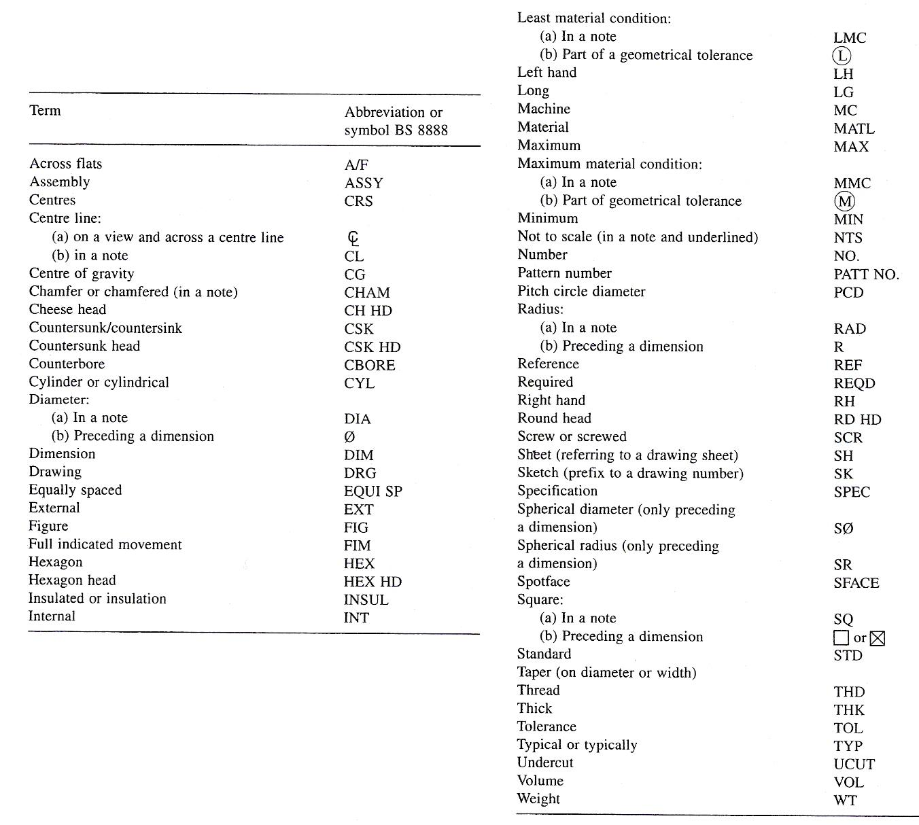
Figure 27 - Abbreviations

Self Assessment
Questions on Background Notes – Module 6.Unit 3

1. In relation to line type and convention in technical drawing sketch:

- Line representing Hidden Detail.
- Break Line.
- Hatching lines.

2. In relation to drawing scales what does the Word/Numbering Scale 1:5 mean?

- In diagram form sketch the symbol applied to working drawing, welding symbols:

- Fillet Weld.
- Square Butt Weld.
- Plug Weld.
- Spot Weld.
- Seam Weld.
- Single U Butt Weld.

4. Give the abbreviations for the following terms:

- Centre Line.
- Diameter.
- Centres.
- Left-Hand /Right-Hand.
- Reference.
- Standard.
- Tolerance.
- Weight.
- Volume.

Answers to Questions 1-4. Module 6. Unit 3
1.

a Hidden Details:

b. Break Lines:

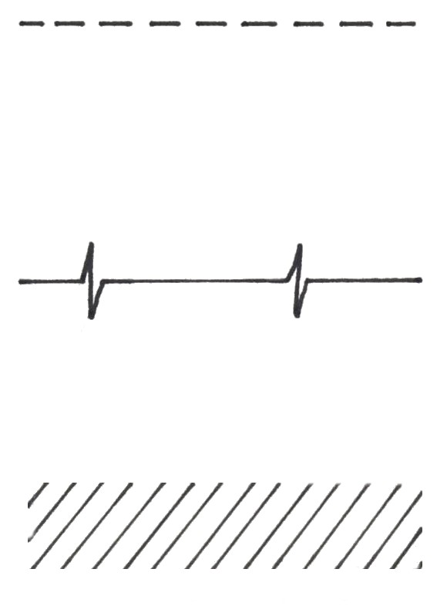
c. Hatching Lines:

2.

Scale 1:5

Each 1mm on the drawing represents 5mm on the item being drawn.

3.

Square Butt Weld | 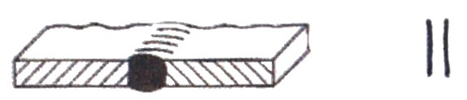
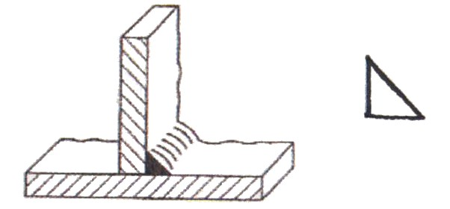

Fillet Weld

Plug Weld | 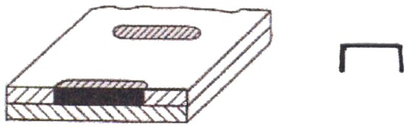
Spot Weld | 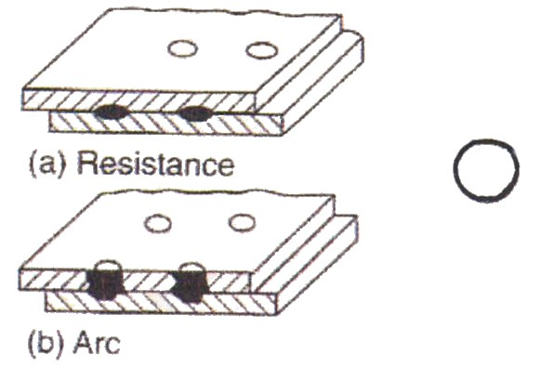
Seam Weld | 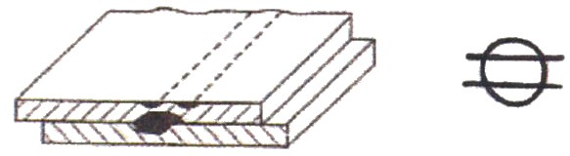

Figure 7.

4.

Centre Line On view and cross a centre  line.  In a note. | 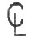  CL
Diameter In a note.  Preceding a dimension | DIA  Ø
Centres | CRS
Left-Hand  Right-Hand | LH  RH
Reference | REF
Standard | STD
Tolerance | TOL
Weight | WT
Volume | VOL

Index

A
Abbreviations, 29
Application of Welding Symbols to Working Drawings, 10
D
Drawing Diagonal Scales, 13
Drawing Layouts and Simplified Methods, 17
Assembly Drawings, 20
Collective Assembly Drawing, 21
Collective Single-Part Drawings, 17
Combined Details and Assembly Drawings, 22
Design Layout Drawings, 21
Exploded Assembly Drawings, 22
Machine Drawing, 25
Simplified Drawings, 23
Single-Part Drawing, 17
Drawing Scales, 12
L
Lines, 9
Height of Lettering, 9
S
Self Assessment, 30
Standards and Conventions, 11
T
Types of Lettering, 8
U
Use of Grid Technique, 14

